**Calorie/Weight Management**

**Jamaine Cotton Jibril Stewart**

**This app is about keeping track of the number of calories our bodies in take. We can use that information to gauge the number of calories both daily and weekly we need to consume. To either gain or lose weight. This is compared to a weight loss program. Difference is, you’re not exactly getting in depth with a strict meal plan or cutting out your favorite foods. Mainly observing the calorie amount each food item you consume has, to stay on track with your weight gain/loss.**

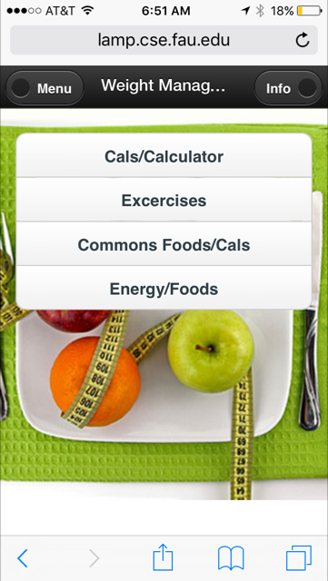

**From the menu page, there are different options you can use to gain more knowledge about how managing calories with gaining/losing weight works.**

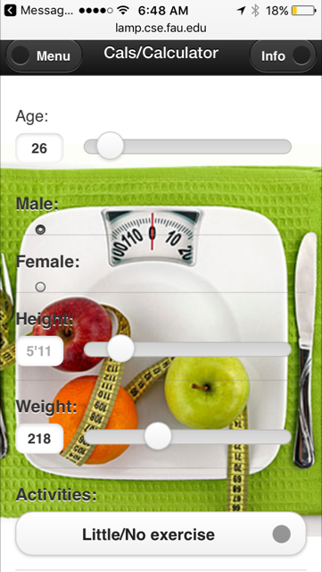

**The BMR calculation tab calculates your basal metabolic rate. Using the information you input such as, your height, weight, age, gender and the intensity of your weekly activities. Once calculated there will be a reference to the number of calories you must add/subtract to your calculated BMR to gain/lose weight.**

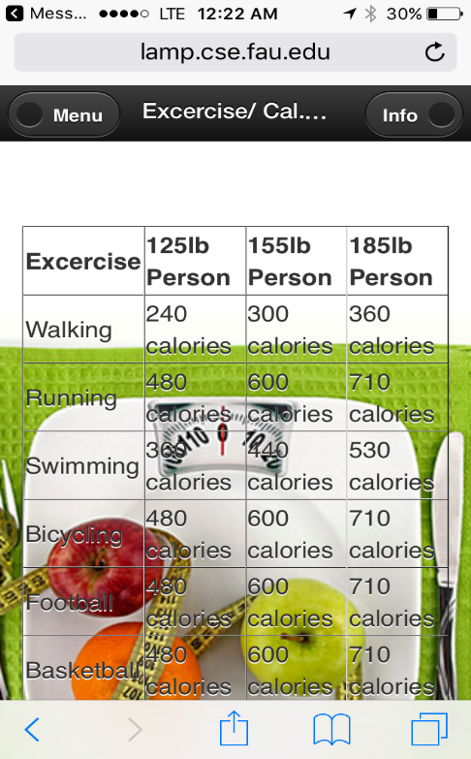

**Exercise/Calorie Burn, this table has a few exercises that can be used to burn calories and the number of calories each exercise burns. This is also based on the weight of the person.**

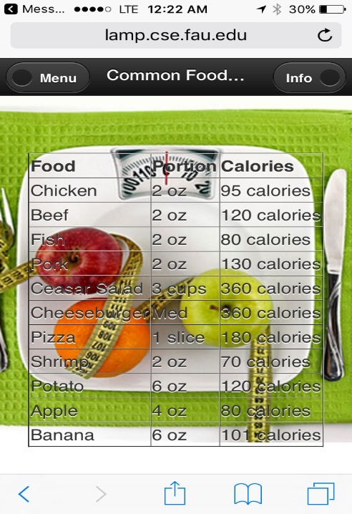

**Common food/Calories tab, gives information of a few foods and their calories in a portion. This will better help you manage eating your favorite foods and not gain weight if you’re trying to lose weight.**

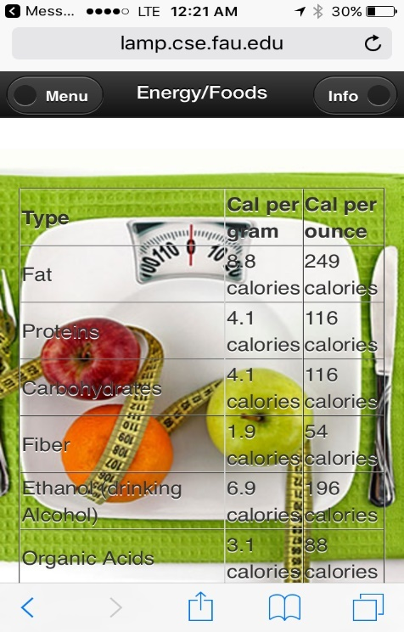

**Energy/Foods page has a list of food that shows the amount of energy gained through consumption. When it comes the energy within foods, it allows you to know what foods or types of foods gives a certain amount of energy. This energy is used to help maintain a healthy metabolism and promotes good muscle function.**

**This is all we've come up with for the creating this app. Making it easier on having a balanced diet and controlling the number of calories consumed. No more cutting out your favorite foods with the little depth in knowledge that can be gained using our app.**

Reference Page

http://lamp.cse.fau.edu/~jstewa50/classProjectApp/

<http://www.wikihow.com/Calculate-Your-Total-Daily-Calorie-Needs>

<https://en.wikipedia.org/wiki/Food_energy>

<http://www.calculator.net/calorie-calculator.html>

**appetite_control_460 image retrieved from site below:**

<http://nutrition21.com/item/appetite-control-weight-management/>

**Github link:** <https://github.com/ckstewart/Weight-Management/tree/master/projectAssignments>

**Building Cross-Platform Mobile and Web Apps for Engineers and Scientist**